**Sample Randomly Generated Sudoku’s**

Sudoku’s by: Joe Carlson, Max Beyer, Amy Loreen, Kyle Schaplowsky

**Easy:** **Medium:**

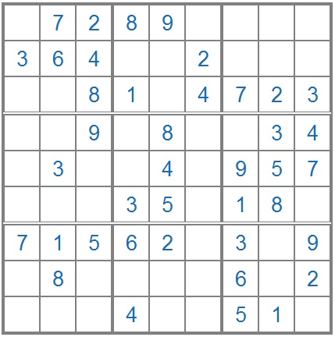 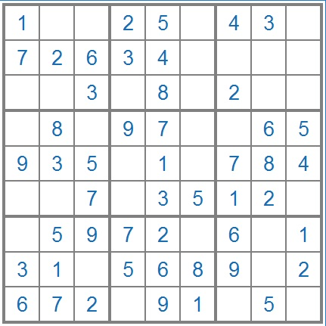

**Hard:** **Insane:**

